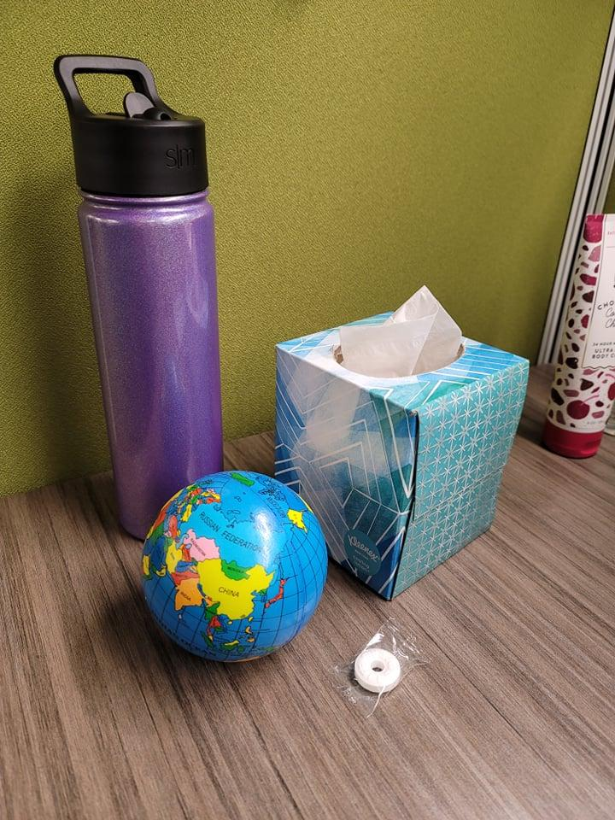

The first object that will be created in 3D is the water bottle. This is a good choice for my work because it is a basic shape with a slight complexity added to it from the handle and straw extender.. The next object that will be created in 3D is a tissue box. The next object that will be created in 3D is a globe. This is a good choice because it is a simple shape that will not require much fuss to add extra features to make it legible. Finally, the last object to be made in 3D is a life saver. This is a more difficult choice because of the shape of the wrapper, and will challenge me to utilize multiple shapes to create the overall image.

The water bottle is mainly a cylinder shape, but some complexity is added with the lid. I will need to alter some other shape types to capture the handle and straw extension. The tissue box can be made using a cube shape, but alterations will be needed for the tissue sticking up out of the box. The globe will use a sphere to capture the shape of the object. I will use a torus to capture the shape of the candy, and two modified planes or rectangles to create the wrapper around it. I will also use two planes to create the desk surface and the wall behind the scene.